|  |  |  |  |
| --- | --- | --- | --- |
| **SL/NO** | **NAME OF THE FACILITIES UNDER AIZAWL WEST DISTRICT** | **GRIEVANCE RECIEVED** | **GRIEVANCE ADDRESS** |
| 1 | DHT CMO WEST | NIL | NIL |
| 2 | Sialsuk PHC | NIL | NIL |
| 3 | Aibawk PHC | NIL | NIL |
| 4 | Chawlhhmun UPHC | NIL | NIL |
| 5 | Kulikawn SDH | NIL | NIL |
| 6 | Lengpui PHC | NIL | NIL |
| 7 | Sairang PHC | NIL | NIL |
| 8 | Lawipu UPHC | NIL | NIL |

**QUARTERLY GRIEVANCE REDRESSAL REPORT**

**FACILITIES UNDER CMO AIZAWL WEST DISTRICT GRIEVANCE REPORT OF: YEAR 3 QUARTER 2 (April, May, June) 2024**

* **Grievance received: No**
* **Grievance address: No**

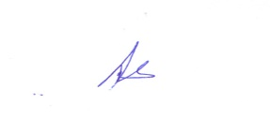

(DR. LALBIAKSIAMI)

Sr.Chief Medical Officer

Aizawl West District